Solution Architecture

Date | 15 July 2026
Team ID | XXXXXX
Project Name | FloodGuard - AI/ML Flood Prediction System
Maximum Marks | 5 Marks

Solution Architecture Diagram
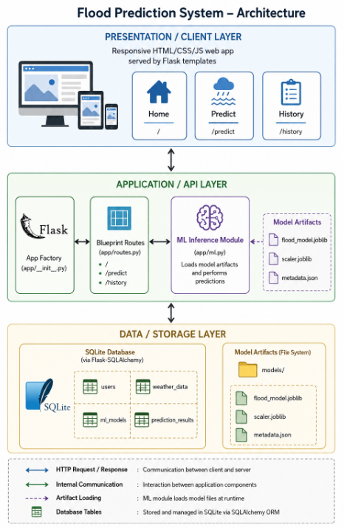
Component Description Table
Component Name | Description / Role | Technologies Used
Presentation Layer | Renders the home, prediction, and history pages; submits weather data via AJAX and displays results dynamically | HTML5, CSS3, JavaScript (Fetch API), Jinja2 templates
API / Routes Layer | Exposes /, /predict, /history and the POST /api/predict JSON endpoint; validates input and orchestrates the prediction flow | Flask 3.1, Flask Blueprints
ML Inference Module | Loads the trained model + scaler once at startup and runs predict_flood() for each request | scikit-learn / XGBoost, joblib, pandas
Training Pipeline | Offline pipeline that cleans data, trains 4 candidate models, compares them, and persists the best one | pandas, scikit-learn, XGBoost, matplotlib, seaborn
Database Layer | Persists users, weather submissions, registered models, and prediction results | SQLite, Flask-SQLAlchemy (ORM)
Deployment | Hosts the Flask app on a public URL, auto-deploying on every GitHub push | Render (Web Service), Gunicorn WSGI server, GitHub

